**Collected Data**

FEATURES:

The data consists of 6 options, each of them user can use to collect the data from Google music account. This options are:

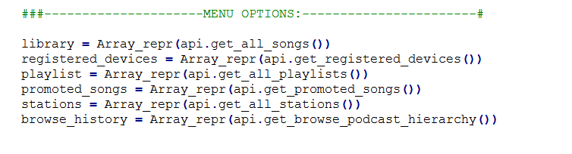

EXAMPLE:

The table below shows the part of the code and shows how program works representing all user`s songs in 1d array:

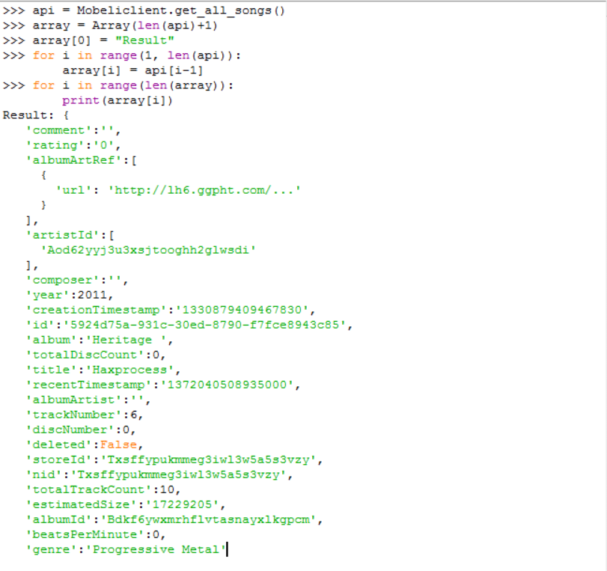

RESULTS OF RESEARCH:

After the research, I have analyzed test account(my account) on the playlists capacity also monitored my browse history, also seen my most liked songs and stations that I use to listen to music. So, as we see, by using it everyone is able to analyze an account that has access to and It`s really easy.